AUDITOR, Maricar L. 2ECE-D

**PANDAS**

Problem 1

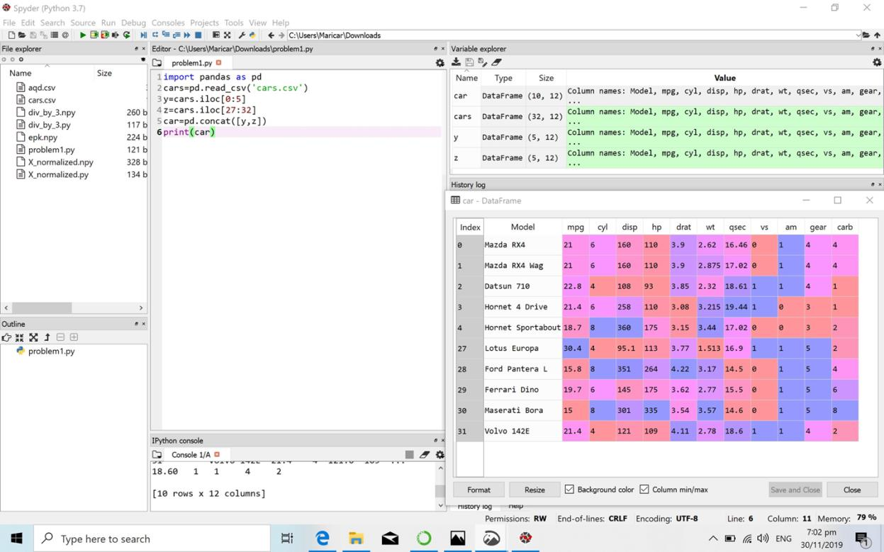

Problem 2A

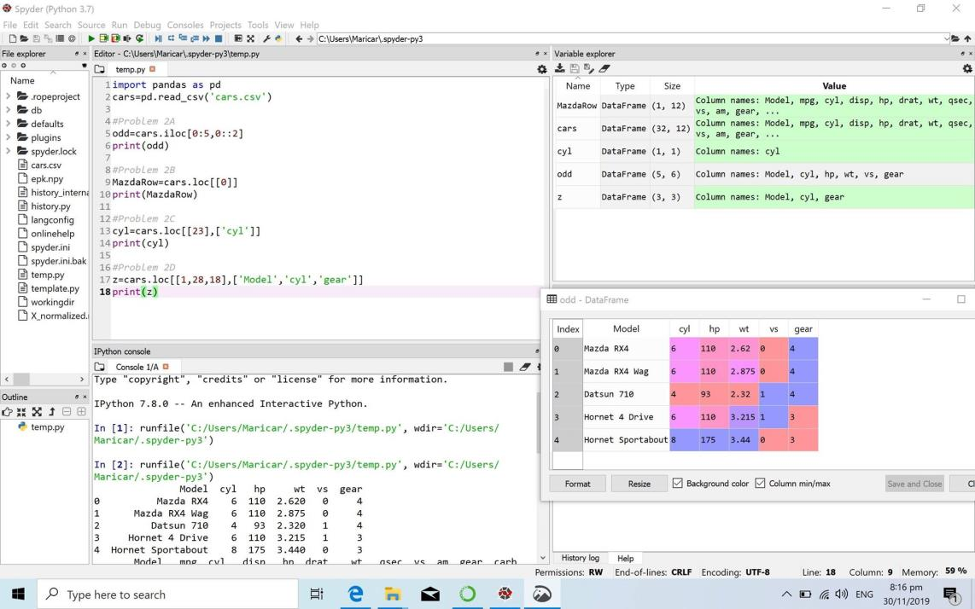

Problem 2B

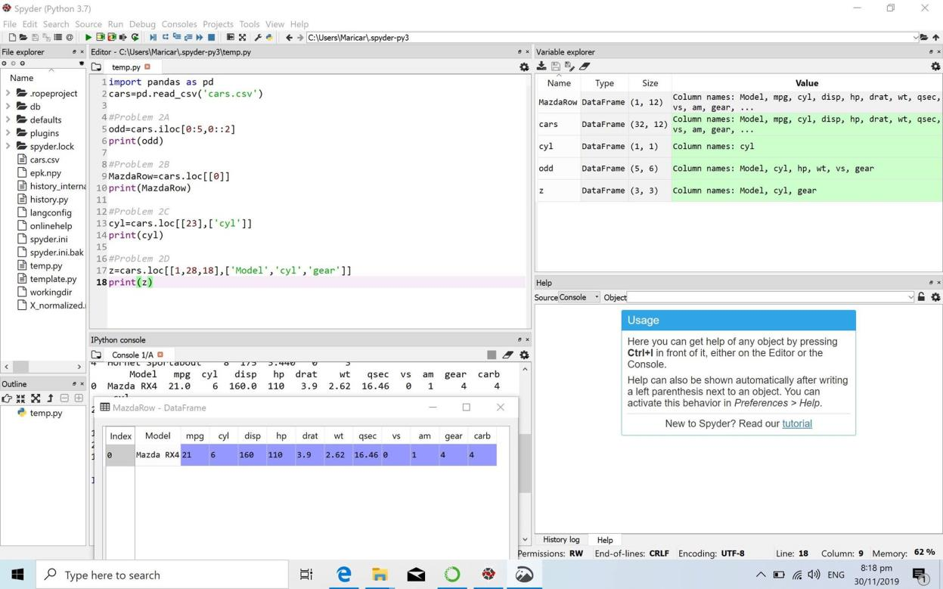

Problem 2C

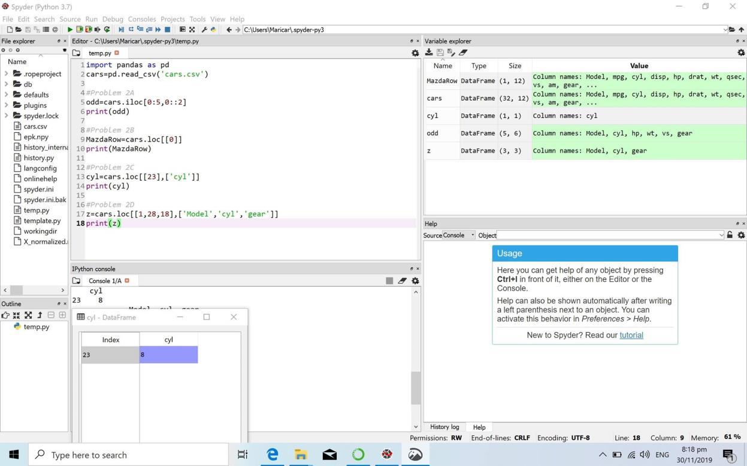

Answer: Camaro Z28 has 8 cylinders

Problem 2D

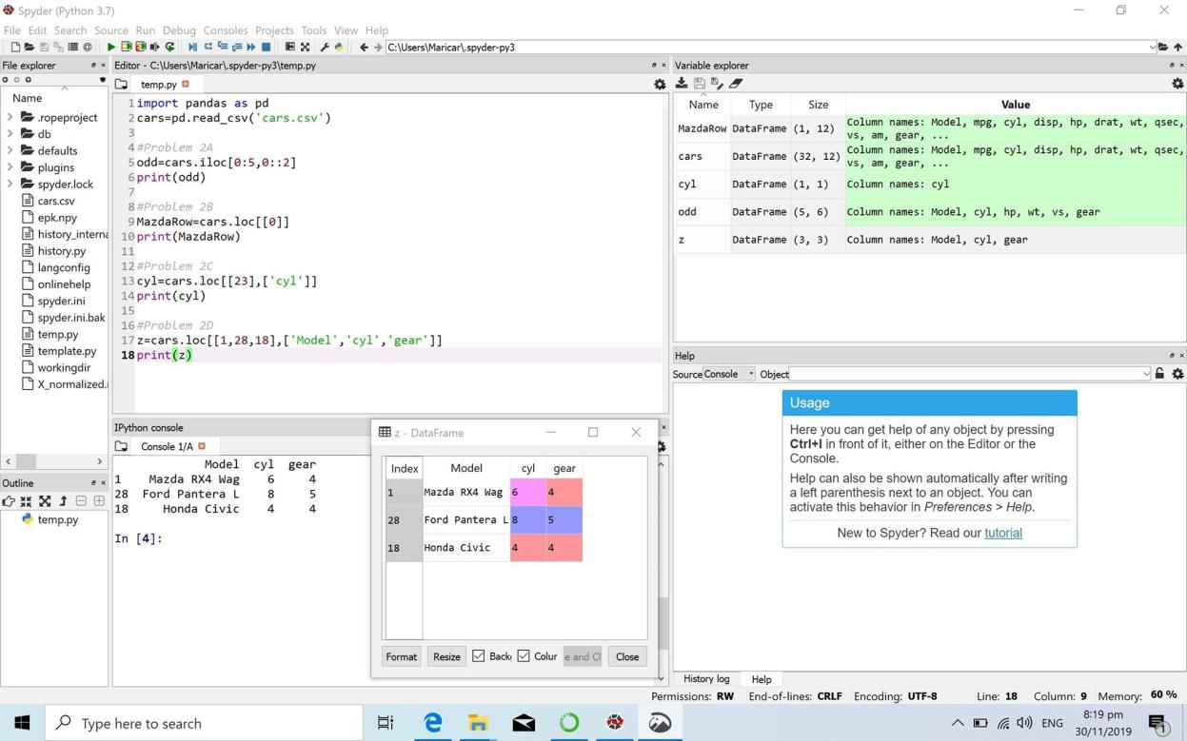

Answer:

Mazda RX4 Wag has 6 cylinders and a gear type of 4.

Ford Pantera L has 8 cylidiners and a gear type of 5.

Honda Civic has 4 cylinders and a gear type of 4.